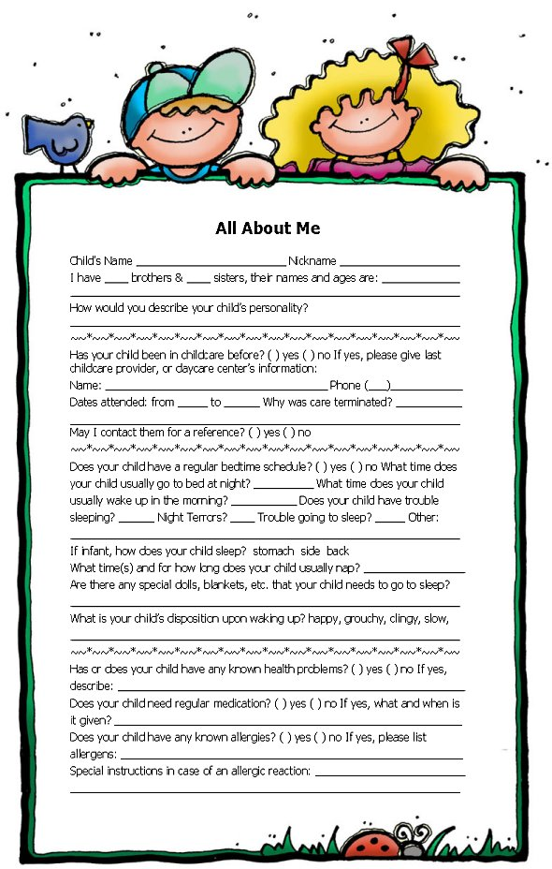

**All About Me!**

Child’s Name ____________________________ Nickname ____________________________

I have _____ brothers & _____ sisters, their names and ages are: ________________________

_____________________________________________________________________________

How would you describe your child’s personality?

Has your child been in child care before? ( ) Yes ( ) No. If yes, please give last child care provider, or daycare center’s information:

Name: ________________________________________ Phone _________________________

Dates Attended: from ________ to _________. Why was care terminated? ________________

_____________________________________________________________________________

May I contact them for a reference? ( ) Yes ( ) No

Does your child have a regular bedtime schedule? ( ) Yes ( ) No. What time does your child usually go to bed at night? ___________. What time does your child usually wake up in the morning? __________. Does your child have trouble sleeping? ( ) Yes ( ) No. Night Terrors?

( ) Yes ( ) No. Trouble going to sleep? ( ) Yes ( ) No. Other: ____________________________

_____________________________________________________________________________

If infant how does your child sleep? ( ) Stomach ( ) Side ( ) Back. What time(s) and for how long does your child usually nap? ___________________________________. Are there any special dolls, blankets, etc that your child needs to go to sleep? __________________________

What is your child’s disposition upon waking? ( ) Happy ( ) Grouchy ( ) Clingy ( ) Slow

( ) Other _____________________________________________________________________

Has or does your child have any known health problems? ( ) Yes ( ) No. If yes, please describe: _____________________________________________________________________________

Does your child need regular medication? ( ) Yes ( ) No. If yes, what and when is it given?

_____________________________________________________________________________

Does your child have any known allergies? ( ) Yes ( ) No. If yes, please list allergens:

_____________________________________________________________________________

Special instructions in case of an allergic reaction: ____________________________________

_____________________________________________________________________________



Has your child had any of the following communicable diseases? ( ) Chicken Pox ( ) Measles

( ) Mumps ( ) Other ____________________________________________________________

Is your child prone to ( ) Upset Stomach ( ) Colds ( ) Ear Aches ( ) Headaches ( ) Sore Throat

( ) Other _____________________________________________________________________

Are there any indications of hearing or vision problems? ( ) Yes ( ) No. If yes, please describe:

_____________________________________________________________________________

Has your child had any recent illnesses? ( ) Yes ( ) No. If yes, please describe: _____________

_____________________________________________________________________________

Does your child have any physical or mental disabilities? ( ) Yes ( ) No. If yes, please describe:

_____________________________________________________________________________

Do you have a backup plan if your child is ill and cannot attend daycare, or becomes ill and must be picked up from daycare? ( ) Yes ( ) No

What are your child’s eating habits (e.g. picky eater, eats anything, time usually eats, etc)?

_____________________________________________________________________________

If infant, what kind of formula does your child drink? _________________________________

Child’s usual dining habits: ( ) High Chair ( ) Booster Seat ( ) Feeds Self ( ) Uses Utensils

( ) Bottle ( ) Sippy Cup ( ) Regular Cup ( ) Other _____________________________________

Does your child eat unaided? ( ) Yes ( ) No. Does he/she enjoy eating? ( ) Yes ( ) No

Does your child have a special diet? ( ) Yes ( ) No. Due to your child’s tastes, allergies, reactions, and/or religious beliefs, are there any foods that should not be served to your child?

( ) Yes ( ) No. If yes, please list foods: _____________________________________________

Favorite foods: ________________________________________________________________

Disliked foods: ________________________________________________________________

Where will your child usually eat breakfast? ( ) Daycare ( ) Home

Is there is anything else special or otherwise you would like us to know about your child?

_____________________________________________________________________________

_____________________________________________________________________________

_____________________________________________________________________________

_____________________________________________________________________________

_____________________________________________________________________________

PLEASE SEND A FAMILY PICTURE WITH THIS COMPLETED FORM ! 😊 ____________________________________________________________________